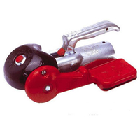
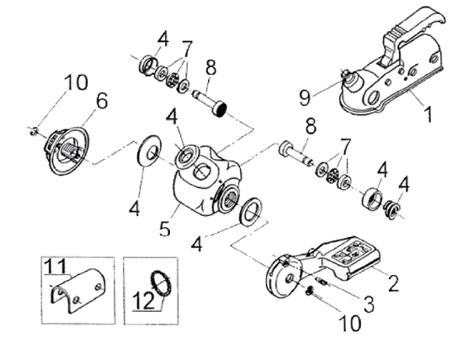
Ref | Description | Part Number
2 | Operating lever | 603379
3 | Retaining screw | 603153
4 | Seal kit, 5 pieces +1 spring | 246340
6 | Ratchet hand wheel | 614358
7 | Bearing set | 246338
8 | Friction pad kit | 638057
9 | Safety indicator button | 246341
10 | Split rings, 2PK + 2 spare | 246337

