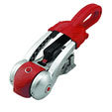
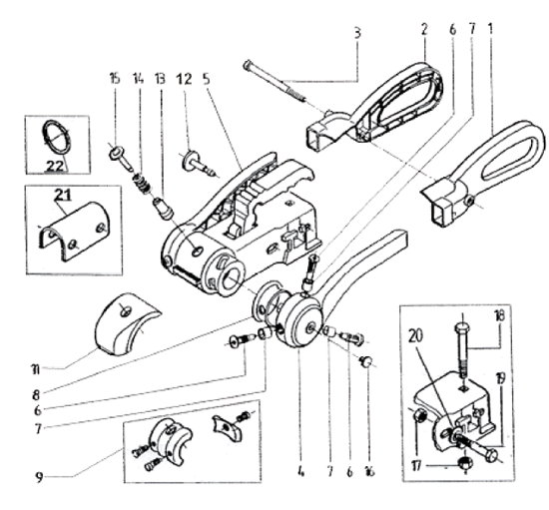
Ref | Description | Part Number
1 | Handle LH | 690243
2 | Handle RH | 690244
4 | Arm LH | 690241
5 | Arm RH | 690242
7 | Bearing | 380307
8 | Seal | 372166
9 | Friction pad kit, Front & rear | 121216
12 | Friction pad kit, Side | 287763
13 | Indicator button, inner | 372288
14 | Springs | 372285
15 | Indicator button, outer | 372287

